# Zero Waste Plan

## Event Details

**Event Name:**

**Event Date and Time:**

**Event Location:**

**Expected Attendance:**

**Key Activations on Site:**

**Contact Name:**

**Contact Details:**

## Key Stakeholders NS their commitment to Zero Waste

|  |  |
| --- | --- |
| Stakeholder | Commitment to Zero Waste |
| **Whangarei District Council** | Development of Sustainability Strategy. Commitment to green events. |
| **Eco-Solutions** | Providing advice and support on the day, briefing the volunteers |
| **Waste Management** | Contracted to provide the bins. Collection of waste and recycling. |
| **Garden Waste Solutions** | Organic Waste Collection |
| **Stall Holders** | Large commitment through the registration process. Only those on board with the Zero Waste Kaupapa can be involved. Ensuring the amount of non-recyclable products coming on site into the festival are minimised. |
| **Surrounding Businesses** | Will ensure their waste doesn’t come into the festival. |
| **Volunteers** | ## volunteers giving up their time to be Recycling Ambassadors at the festival, ensuring waste and recycling is not contaminated. |
|  | Post event clean, will ensure waste and recycling is separated. |
| **Attendees** | Pre-event comms and promotion. |

## Bin Types and Waste Streams Expected

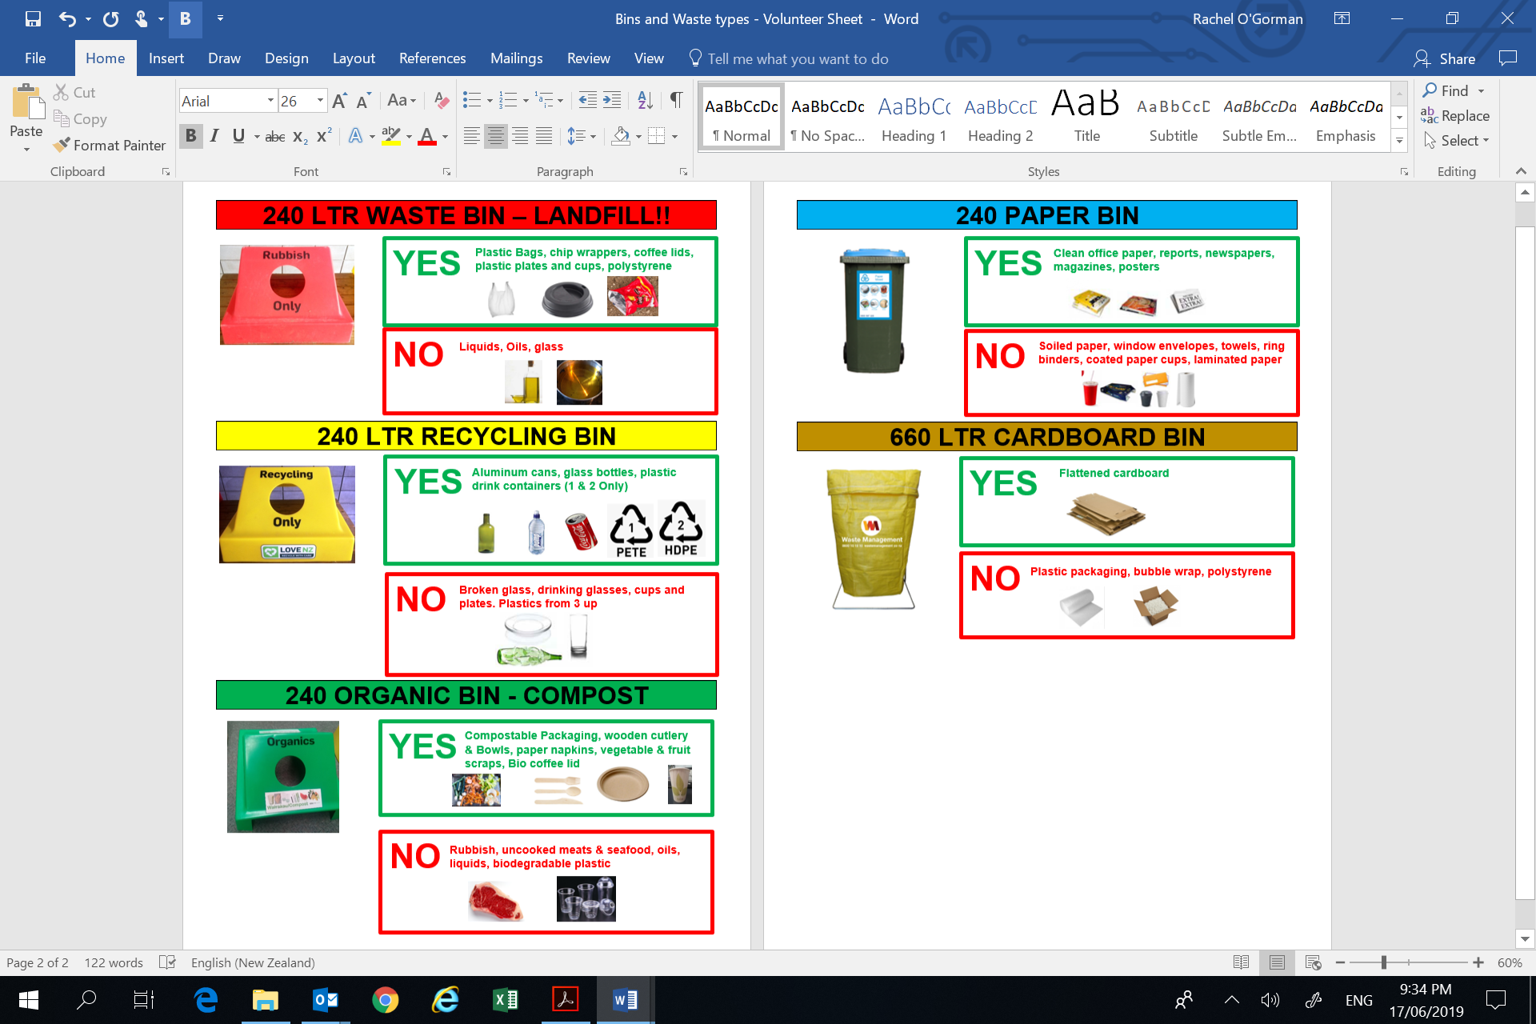

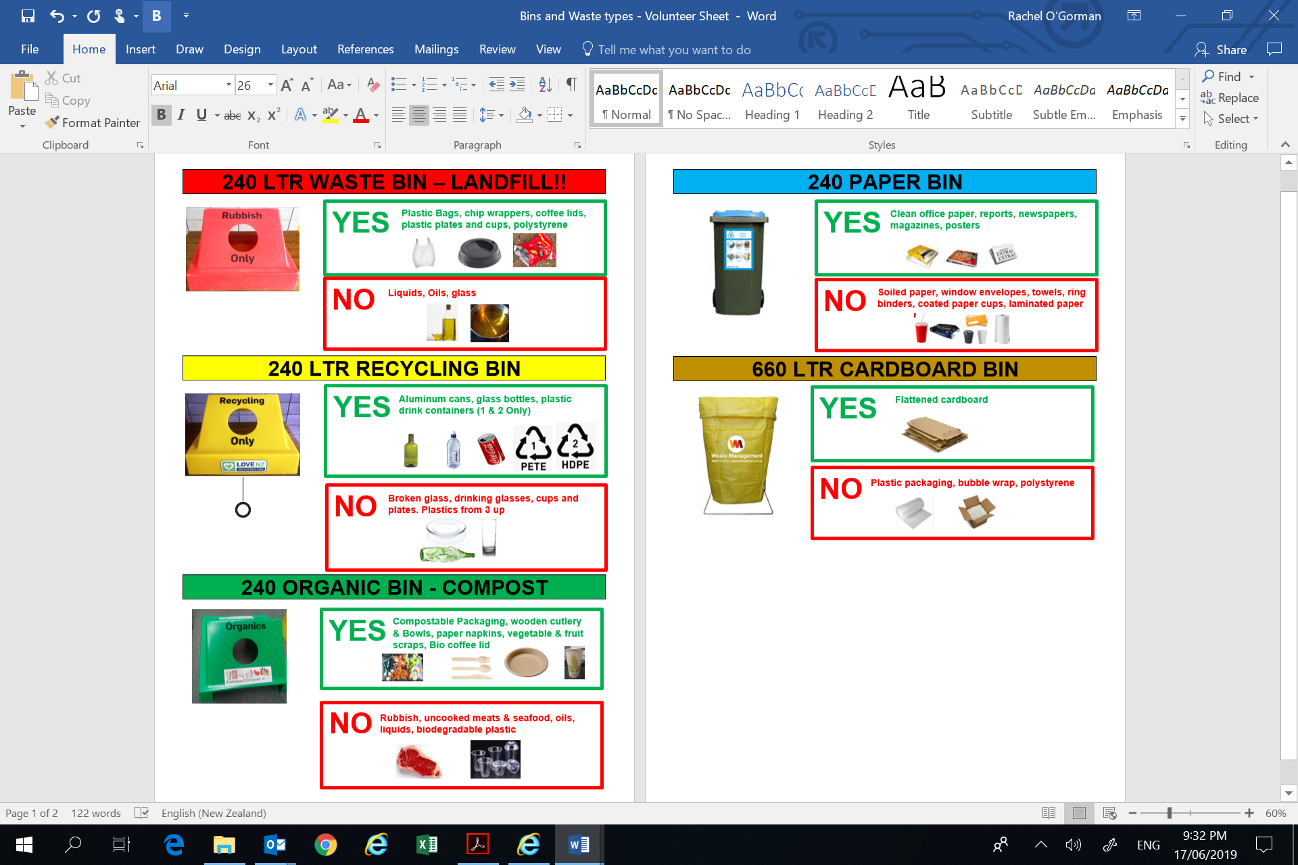

## Collection System Management

|  |  |  |
| --- | --- | --- |
| Bin / Lid / Waste | Delivery Details | Collection Details |
| 240 Ltr Bins - Waste, Organic, Recycling, Paper. Cardboard Bins | Supplied and delivered by: Organisation  Delivered to: Location  Date and Time: Date and time  Contact: Name and phone number | Collected by: Organisation  Date and Time: Date and time  Notes: Any important collection information |
| Waste and Recycling Bin lids | Supplied by: Organisation  Delivered by: Organisation  Date and Time: Date and time | Collected by: Organisation  Date and Time: Date and time |
| Organic Bin Lids | 10 x Organic Bin lids  Supplied and delivered by: Eco-Solutions  22 June 2019, 9:00am  Contact: Name and phone number | Collected by: Organisation  Date and Time: Date and time  Contact: Name and phone number |
| Organic Waste |  | Collected by: Organisation  Date and Time: Date and time  Contact: Name and phone number |

## Communications

*Insert list of communications or screen shots from media / social media*

## Recycling Ambassadors

It is essential that we try and reduce the effect of this event on the environment and therefore *Event Name* will be a **Zero Waste Event**.

One of the most important aspects of delivering a zero-waste event is to have the right people on the ground on the day of the festival.

We will have ## Recycling Ambassadors on site on the day to help the public put their waste into the right bin – whether it’s compost, recycling or landfill. Without having recycling ambassadors on site, all waste including compost and recyclable plastic will likely go straight to landfill.

Each Recycling Ambassador works a # hour shift starting at time, time or time. They receive full training on the day from Organisation and a site induction from organisation.

## Bin Numbers and Locations

|  |  |  |  |  |  |  |
| --- | --- | --- | --- | --- | --- | --- |
| Bin Station Number | Location | Waste 240 Ltr | Recycling 240 Ltr | Organic 240 Ltr | Paper 240 Ltr | Cardboard 660 Ltr |
| 1 | List locations |  |  |  |  |  |
| 2 |  |  |  |  |  |  |
| 3 |  |  |  |  |  |  |
| 4 |  |  |  |  |  |  |
| 5 |  |  |  |  |  |  |
| 6 |  |  |  |  |  |  |
| 7 |  |  |  |  |  |  |
| 8 |  |  |  |  |  |  |
|  |  |  |  |  |  |  |
| Totals | |  |  |  |  |  |

## Bin Locations

*Insert Site map showing where bin stations will be located*